**Specification of 49-inch square screen Android all-in-one machine**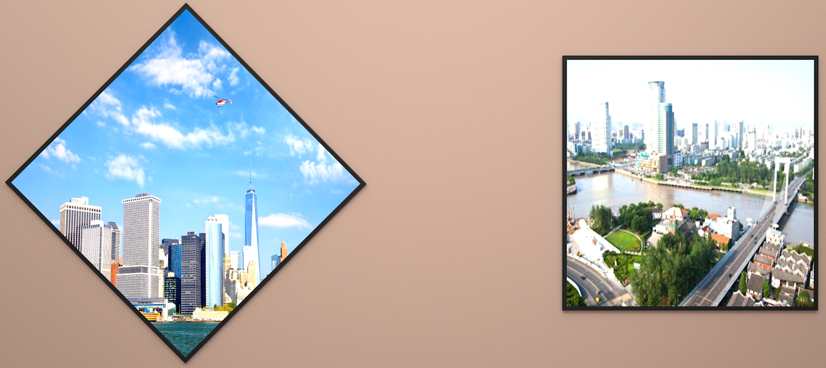

|  |  |
| --- | --- |
| **Android system hardware configuration** | |
| Main chip model | RK3288 |
| Central processing unit (CPU) | Cortex-A17 Quad-Core 1.8GHz |
| Image processor (GPU) | Mali-T764 |
| Running memory (RAM) | 2GB |
| System memory (ROM) | 8GB(16G optional, maximum support 64GB) |
| Version | Android 5.0 or above |
| Other functions | Customize the square/diamond UI operation interface |
| **Mainboard input/output interface** | |
| USB input | 2 channels (Type-A USB2.0 x2 channels) |
| audio output | 1-way analog headset |
| Extended storage | 1 (TF card standard socket) |
| Network input | * 1 standard RJ45 wired Ethernet port |
| Sim card slot | 1 wireless 2.4G Wi-Fi |
| video output | 1 SIM card slot (optional for 3G/4G modules) |

|  |  |
| --- | --- |
| **Display performance parameters** | |
| product model | JS449A01 |
| product size | 44.9 inches |
| Display size (mm) | 86.4 high x 806.4 high |
| the physical resolution | 1280 x 1280 |
| Point distance (mm) | 0.63 height x0.63 width |
| Peak brightness of whole machine | 700cd/㎡ 50 |
| Dynamic contrast | 4000:1 |
| Viewing angle (square H/V) | 178 /178 |
| Display color | 16.7m (8 places) |
| refresh rate | 50 Hz |
| Response time | 8ms |
| **Electrical performance of the whole machine** | |
| Power input | AC 220V ~50Hz |
| Power supply hard switch | support |
| Power consumption of the whole machine (excluding 4G module) | ≥96W |
| Loudspeaker power | 2x2W (rated power) |
| Installation mode | wall hanging |
| Material | panel beating |
| Appearance color | Black (default) |
| Working temperature | 0-50℃ |
| Working humidity | 10-90%RH (non-condensing) |
| Storage temperature | -10-60℃ |
| Storage humidity | 10-90%RH (non-condensing) |

**Six-side view installation dimensions**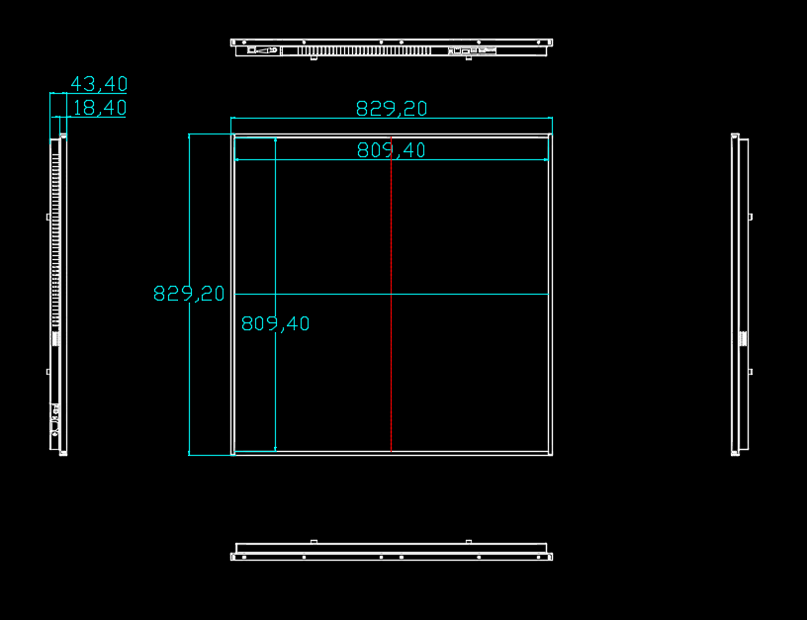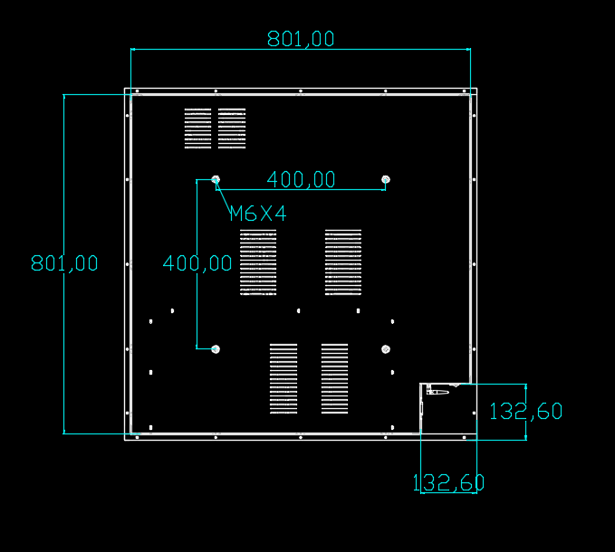

|  |  |  |
| --- | --- | --- |
| **Structure size (unit: mm)** | | |
| product model | JS449A01 | |
| Overall dimensions | L830xW830XT43.4 | |
| (length× height× thickness) | ≤19 | |
| Net weight of bare metal (KG) | ≤21 | |
| Gross weight of the whole machine (KG) | L801XW801xT1.5 | |
| Wall mount size | Horizontal 400 x vertical 400 | |
| **packing list** | | |
| Square screen Android all-in-one machine | | 1 set |
| Wall mounting plate | | one |
| Wall screw | | 1 Bao |
| National standard power cord | | 1 article |